MODULE-6
231fa04360@gmail.com

LAB – 1: First Web Api using .Net core
Create a .Net core web application with API template. Use the option to create controller with Read Write permissions. Notice the ValuesController creation with Action methods corresponding to the Action verbs.
On creation of the Web API, execute the application and check if the GET action method result is returned as expected.

Step 1: Click Create a new project. Step 2: Select Project Template
- Search for ASP.NET Core Web API.
- Select the template.
- Click Next.
Step 3: Configure Project Configure the project as follows:
- Framework: .NET 10.0
- Authentication Type: None
- Configure for HTTPS: Checked
- Enable OpenAPI Support: Checked
- Use Controllers: Checked

Click Create.
Step 4: Create Controller with Read/Write Actions.
- Right-click the Controllers folder.
- Select Add → Controller
- Choose API Controller - Empty
- Click Add.
- Enter Controller Name - ValuesController Click Add.

ValuesController.cs:
using Microsoft.AspNetCore.Mvc; namespace FirstWebAPI.Controllers {

[ApiController] [Route("api/[controller]")]
public class ValuesController : ControllerBase { static List<string> values = new List<string>()
{
"Apple",
"Banana", "Orange"
};
[HttpGet]
public IActionResult Get() { return Ok(values);
}
[HttpGet("{id}")]
public IActionResult Get(int id) { if (id >= values.Count)
return BadRequest(); return Ok(values[id]);
}
[HttpPost]
public IActionResult Post(string value){ values.Add(value);
return Ok(values);
}
[HttpPut("{id}")]
public IActionResult Put(int id, string value) { if (id >= values.Count)
return BadRequest(); values[id] = value; return Ok(values);

}
[HttpDelete("{id}")]
public IActionResult Delete(int id) { if (id >= values.Count)
return BadRequest(); values.RemoveAt(id); return Ok(values);
}
}
}

Program.cs:
var builder = WebApplication.CreateBuilder(args); builder.Services.AddControllers(); builder.Services.AddEndpointsApiExplorer(); builder.Services.AddSwaggerGen();
var app = builder.Build(); app.UseSwagger(); app.UseSwaggerUI(); app.UseHttpsRedirection(); app.UseAuthorization(); app.MapControllers(); app.Run();
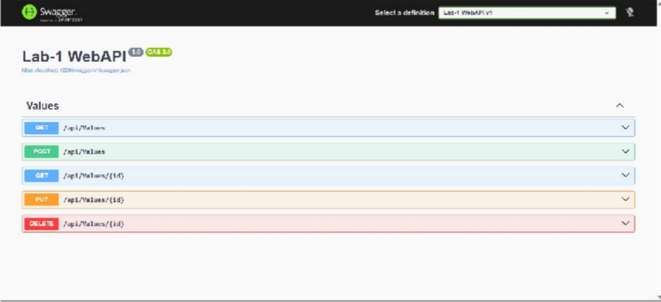

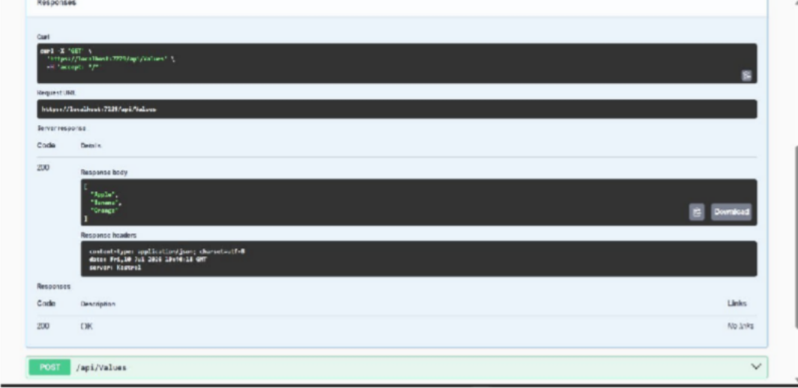

Lab 2 - Web API with Swagger & Postman

Task 1 - Swagger
Step 1: Add Swagger Information Program.cs
var builder = WebApplication.CreateBuilder(args); builder.Services.AddControllers(); builder.Services.AddEndpointsApiExplorer(); builder.Services.AddSwaggerGen(options =>
{
options.SwaggerDoc("v1", new Microsoft.OpenApi.Models.OpenApiInfo
{
Title = "Swagger Demo", Version = "v1",
Description = "Demo Web API",
Contact = new Microsoft.OpenApi.Models.OpenApiContact
{
Name = "John Doe",
Email = "john@xyzmail.com"
}
});
});var app = builder.Build();

app.UseSwagger(); app.UseSwaggerUI(); app.UseHttpsRedirection(); app.UseAuthorization(); app.MapControllers(); app.Run();
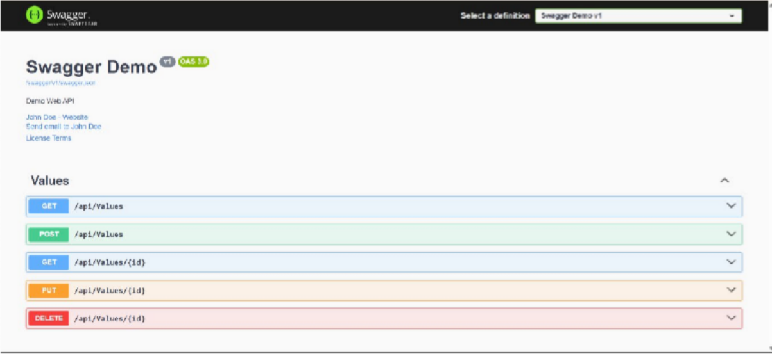

Task 2 - POSTMAN
Step 1: Open Postman. Click New → HTTP Request Step 2: Select GET
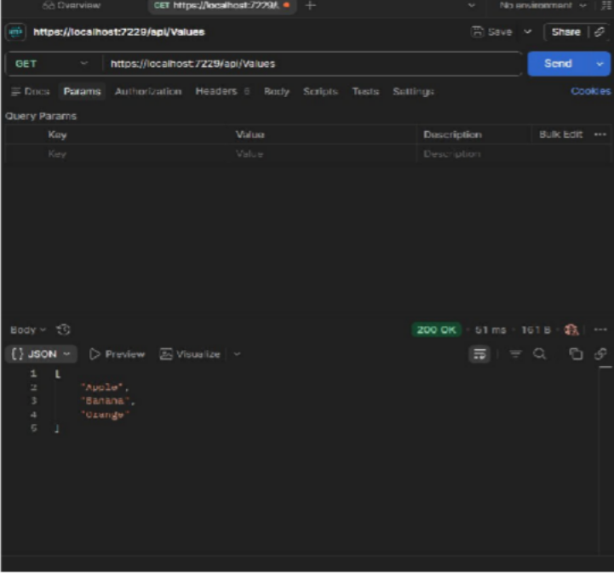
Step 3: Paste https://localhost:7229/api/Values Click Send

Task 3 - Create Employee Controller
Controllers →Add → Controller → API Controller – Empty → name EmployeeController EmployeeController.cs:
using Microsoft.AspNetCore.Mvc; namespace Lab_1_WebAPI.Controllers {
[ApiController] [Route("api/[controller]")]
public class EmployeeController : ControllerBase { static List<string> employees = new List<string>()
{
"Ramesh",
"Suresh", "Mahesh"
};
[HttpGet]
public IActionResult Get() { return Ok(employees);
}
}
}
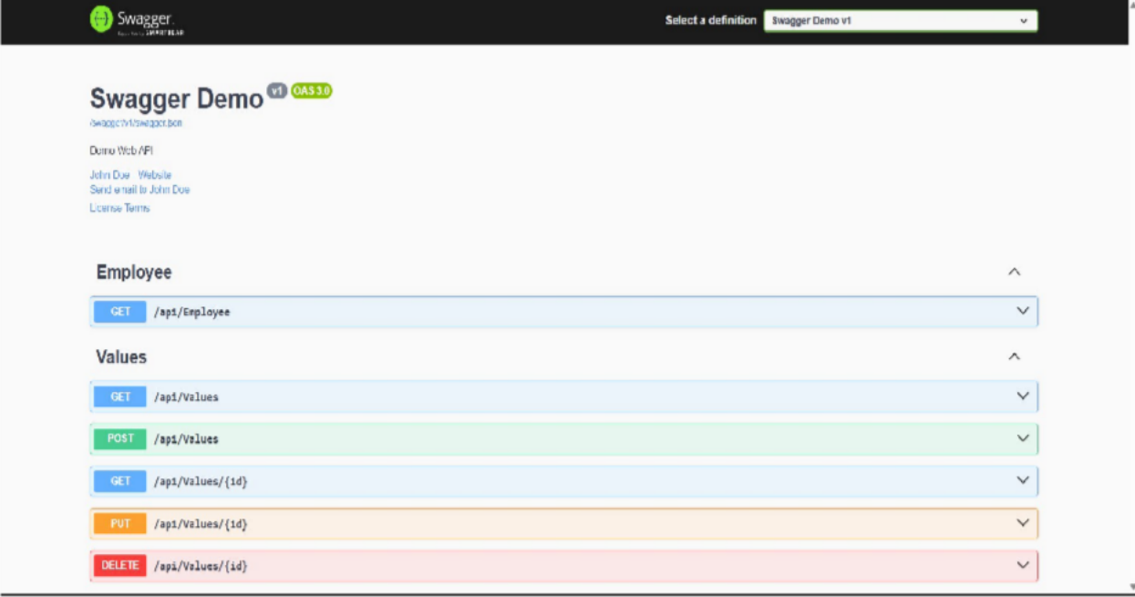

Test in Postman
Method GET
URL: https://localhost:7229/api/Employee Click Send
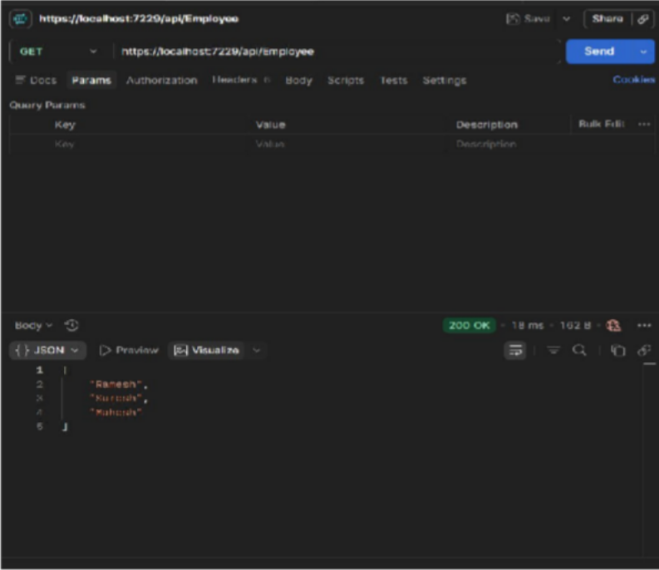

Task 4 - Change Route
Currently: [Route("api/[controller]")]
Change it to: [Route("api/Emp")]
Old URL: https://localhost:7229/api/Employee
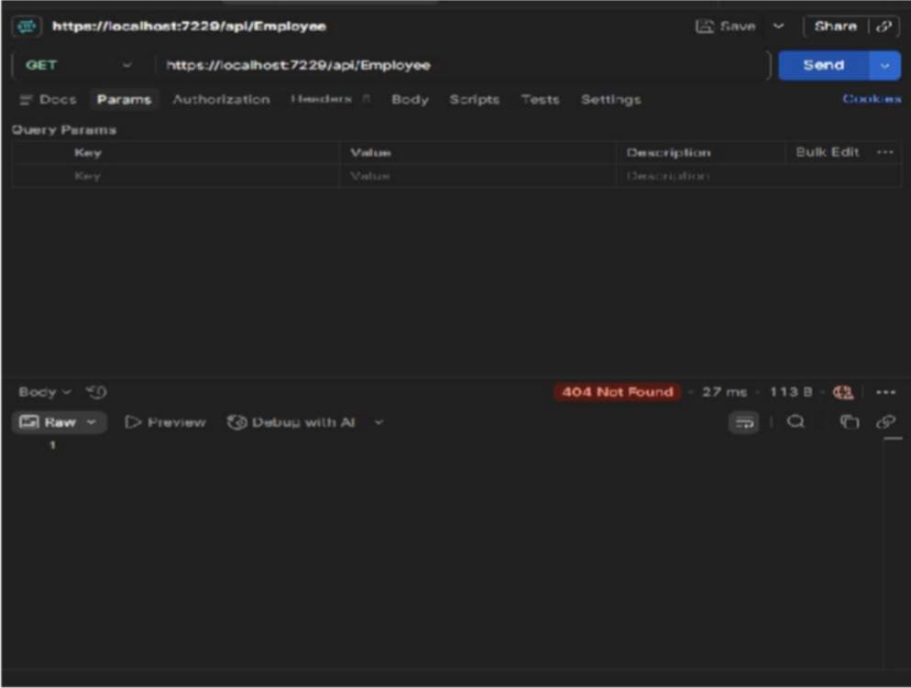

New URL: https://localhost:7229/api/Emp
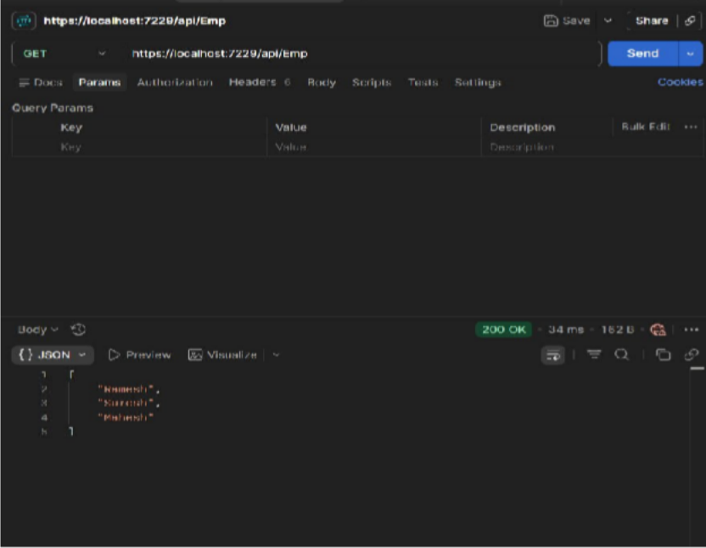

Lab – 3: ASP.NET Core Web API using Custom Model Class, Custom Authorization Filter and Exception Filter
PART – 1: Custom Model Class Step 1 - Create Models Folder
Add → New Folder → Name Models Inside Models Add → Class Department.cs:
namespace Lab_1_WebAPI.Models{ public class Department {
public int Id { get; set; }
public string Name { get; set; }
}
}

Skill.cs:
namespace Lab_1_WebAPI.Models{ public class Skill {
public int Id { get; set; }
public string Name { get; set; }

}
}

Employee.cs:
using System;
using System.Collections.Generic; namespace Lab_1_WebAPI.Models {
public class Employee { public int Id { get; set; }
public string Name { get; set; } public int Salary { get; set; } public bool Permanent { get; set; }
public Department Department { get; set; } public List<Skill> Skills { get; set; } public DateTime DateOfBirth { get; set; }
}
}

EmployeeController.cs:
using Microsoft.AspNetCore.Mvc; using Lab_1_WebAPI.Models;
namespace Lab_1_WebAPI.Controllers { [ApiController] [Route("api/[controller]")]
public class EmployeeController : ControllerBase { private static List<Employee> employees; public EmployeeController() {
employees = GetStandardEmployeeList();
}
private List<Employee> GetStandardEmployeeList() { return new List<Employee> {
new Employee

{
Id=1,
Name="John", Salary=50000, Permanent=true,
DateOfBirth=new DateTime(1999,5,20), Department=new Department {
Id=1,
Name="IT"
},
Skills=new List<Skill>{
new Skill{Id=1,Name="C#"}, new Skill{Id=2,Name=".NET"}
}
},
new Employee
{
Id=2,
Name="David", Salary=60000, Permanent=false,
DateOfBirth=new DateTime(1998,10,12), Department=new Department{
Id=2,
Name="HR"
},
Skills=new List<Skill> {
new Skill{Id=3,Name="SQL"}
}
}

};
}
[HttpGet] [ProducesResponseType(StatusCodes.Status200OK)] public ActionResult<List<Employee>> Get() {
return Ok(employees);
}
[HttpPost]
public IActionResult Post([FromBody] Employee employee) { employees.Add(employee);
return Ok(employees);
}
[HttpPut]
public IActionResult Put([FromBody] Employee employee) {
var emp=employees.FirstOrDefault(x=>x.Id==employee.Id); if(emp==null)
return NotFound(); emp.Name=employee.Name; emp.Salary=employee.Salary; return Ok(emp);
}
} }
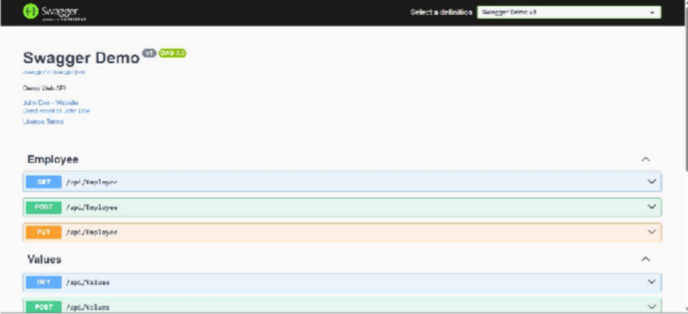

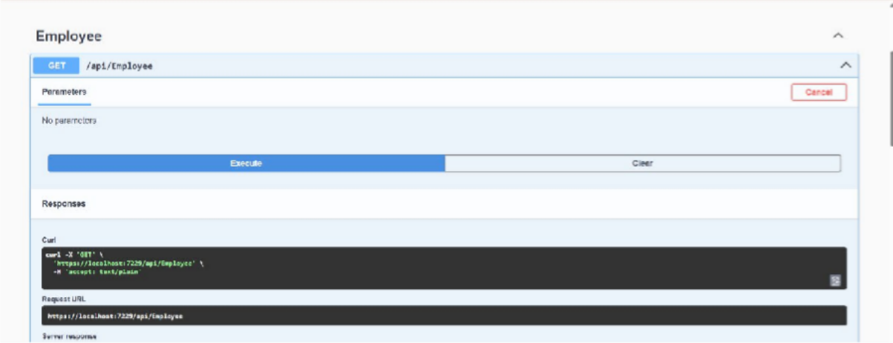
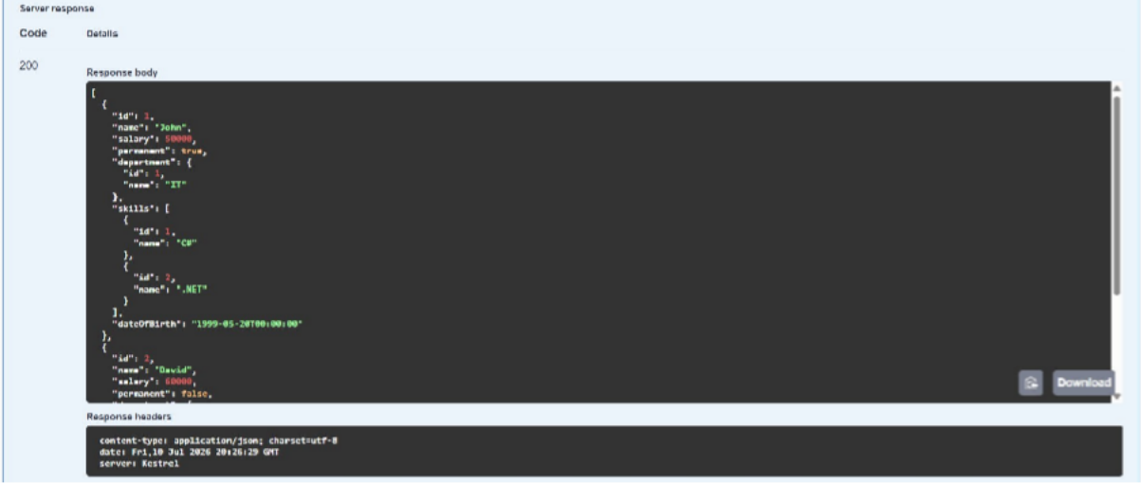
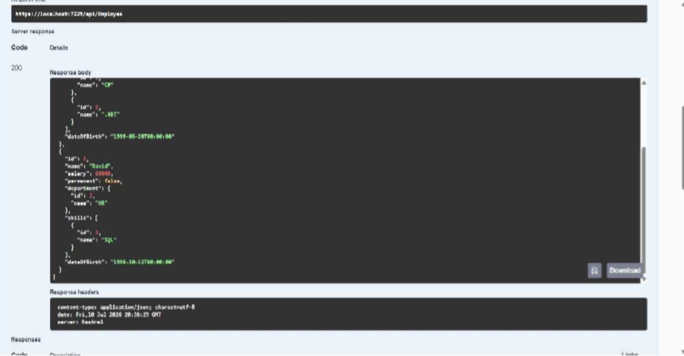

PART - 2: Custom Authorization Filter
Add → New Folder → Name Filters
Inside Filters Add → Class → CustomAuthFilter.cs

CustomAuthFilter.cs:
using Microsoft.AspNetCore.Mvc;
using Microsoft.AspNetCore.Mvc.Filters; namespace Lab_1_WebAPI.Filters {
public class CustomAuthFilter : ActionFilterAttribute {
public override void OnActionExecuting(ActionExecutingContext context) { if(!context.HttpContext.Request.Headers.ContainsKey("Authorization"))
{
context.Result=new BadRequestObjectResult("Invalid request - No Auth token"); return;
}
string token=context.HttpContext.Request.Headers["Authorization"]; if(!token.Contains("Bearer"))
{
context.Result=new BadRequestObjectResult("Invalid request - Token present but Bearer unavailable");
}
}
}
}

EmployeeController.cs:
using Microsoft.AspNetCore.Mvc; using Lab_1_WebAPI.Models;
namespace Lab_1_WebAPI.Controllers { [ApiController]
[Route("api/[controller]")] [CustomAuthFilter]
public class EmployeeController : ControllerBase {

private static List<Employee> employees; public EmployeeController() {
employees = GetStandardEmployeeList();
}
private List<Employee> GetStandardEmployeeList() { return new List<Employee> {
new Employee
{
Id=1,
Name="John", Salary=50000, Permanent=true,
DateOfBirth=new DateTime(1999,5,20), Department=new Department {
Id=1,
Name="IT"
},
Skills=new List<Skill>{
new Skill{Id=1,Name="C#"}, new Skill{Id=2,Name=".NET"}
}
},
new Employee
{
Id=2,
Name="David", Salary=60000, Permanent=false,
DateOfBirth=new DateTime(1998,10,12), Department=new Department{

Id=2,
Name="HR"
},
Skills=new List<Skill> {
new Skill{Id=3,Name="SQL"}
}
}
};
}
[HttpGet] [ProducesResponseType(StatusCodes.Status200OK)] public ActionResult<List<Employee>> Get() {
return Ok(employees);
}
[HttpPost]
public IActionResult Post([FromBody] Employee employee) { employees.Add(employee);
return Ok(employees);
}
[HttpPut]
public IActionResult Put([FromBody] Employee employee) {
var emp=employees.FirstOrDefault(x=>x.Id==employee.Id); if(emp==null)
return NotFound(); emp.Name=employee.Name; emp.Salary=employee.Salary; return Ok(emp);
}
}
}

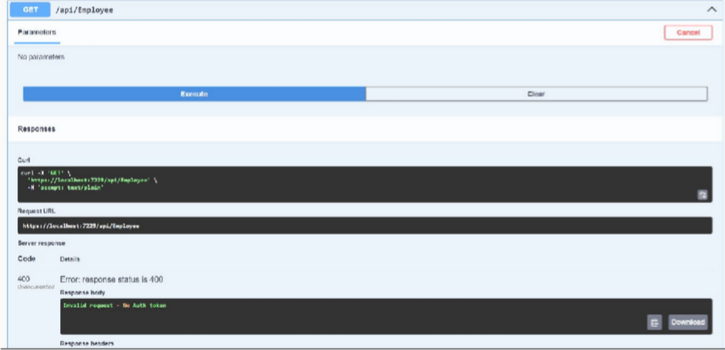

PART - 3: Custom Exception Filter Step 1: Create CustomExceptionFilter.cs Inside Filters folder, create:

CustomExceptionFilter.cs:
using Microsoft.AspNetCore.Mvc;
using Microsoft.AspNetCore.Mvc.Filters; namespace Lab_1_WebAPI.Filters {
public class CustomExceptionFilter : IExceptionFilter { public void OnException(ExceptionContext context) {
string path = Path.Combine(Directory.GetCurrentDirectory(), "ExceptionLog.txt"); File.AppendAllText(path,
DateTime.Now + Environment.NewLine + context.Exception.ToString() + Environment.NewLine +
" " + Environment.NewLine);
context.Result = new ObjectResult("Internal Server Error") { StatusCode = StatusCodes.Status500InternalServerError
};
context.ExceptionHandled = true;
} } }

Step 2: Modify GET method in EmployeeController [HttpGet] [ProducesResponseType(StatusCodes.Status200OK)]
[ProducesResponseType(StatusCodes.Status500InternalServerError)] public ActionResult<List<Employee>> Get() {
throw new Exception("Demo Exception");
}
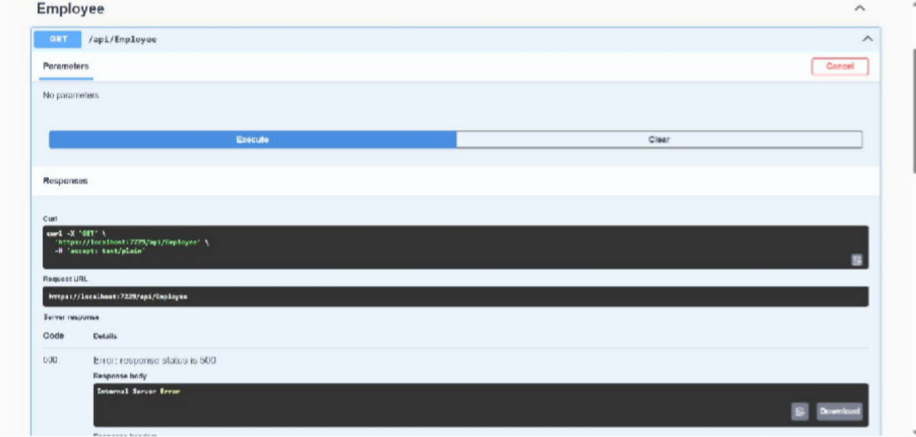

Lab-4: Web Api CRUD operation
Replace methods in EmployeeController.cs PUT:
[HttpPut("{id}")]
public ActionResult<Employee> Put(int id, [FromBody] Employee employee){ if (id <= 0)
{
return BadRequest("Invalid employee id");
}
var emp = employees.FirstOrDefault(e => e.Id == id); if (emp == null)
{
return BadRequest("Invalid employee id");

}
emp.Name = employee.Name; emp.Salary = employee.Salary; emp.Permanent = employee.Permanent; emp.Department = employee.Department; emp.Skills = employee.Skills;
emp.DateOfBirth = employee.DateOfBirth; return Ok(emp);
}

POST:
[HttpPost]
public ActionResult<Employee> Post([FromBody] Employee employee) { employees.Add(employee);
return Ok(employee);
}

DELETE:
[HttpDelete("{id}")]
public ActionResult Delete(int id) { if (id <= 0)
{
return BadRequest("Invalid employee id");
}
var emp = employees.FirstOrDefault(e => e.Id == id); if (emp == null)
{
return BadRequest("Invalid employee id");
}
employees.Remove(emp);
return Ok("Employee Deleted Successfully");
}

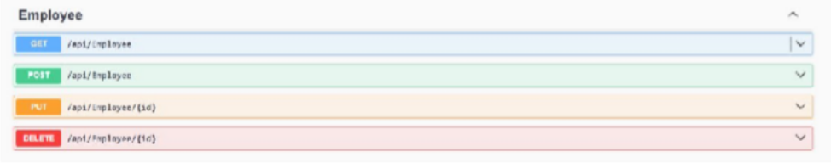

PUT with Valid ID:
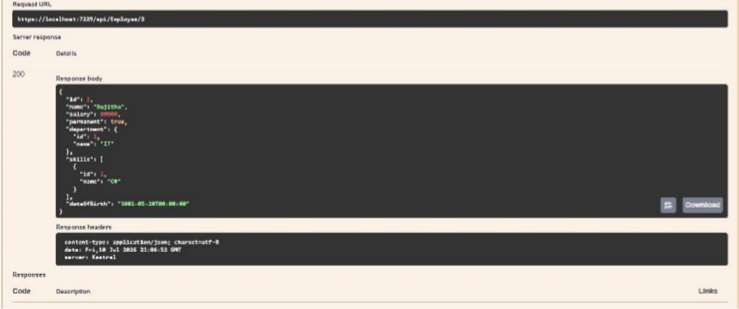

PUT with Invalid ID (100)
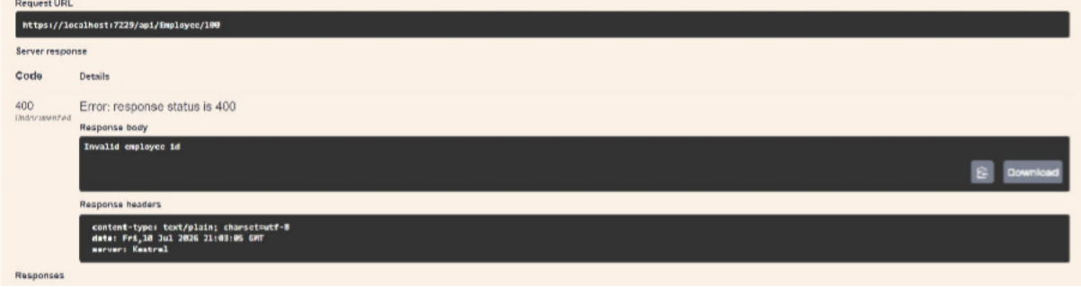

POST
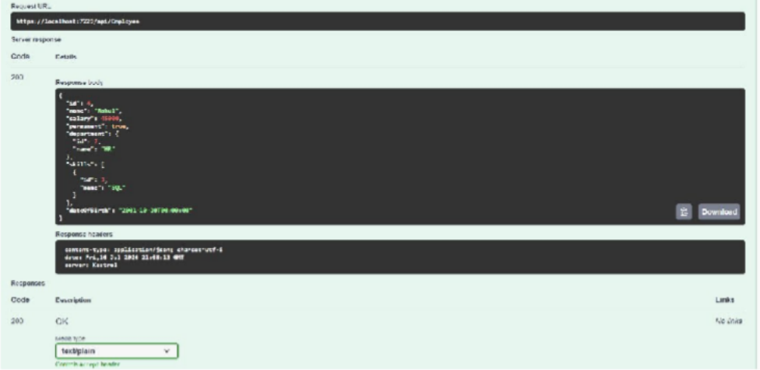

DELETE
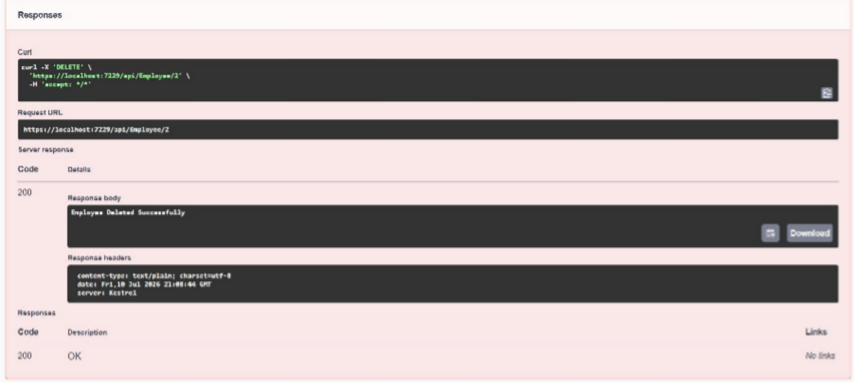

Lab 5 - JWT Authentication

Install NuGet Packages

Install these packages:

  - Microsoft.AspNetCore.Authentication.JwtBearer
  - System.IdentityModel.Tokens.Jwt

Program.cs:

using Microsoft.AspNetCore.Authentication.JwtBearer; using Microsoft.IdentityModel.Tokens;
using System.Text;

using Lab_1_WebAPI.Filters;

var builder = WebApplication.CreateBuilder(args); var securityKey = "mysuperdupersecret";
var symmetricSecurityKey = new SymmetricSecurityKey(Encoding.UTF8.GetBytes(securityKey));

builder.Services.AddControllers(options => { options.Filters.Add<CustomExceptionFilter>();
});

builder.Services.AddEndpointsApiExplorer(); builder.Services.AddSwaggerGen(); builder.Services.AddAuthentication(JwtBearerDefaults.AuthenticationScheme)
.AddJwtBearer(options => {

options.TokenValidationParameters = new TokenValidationParameters { ValidateIssuer = true,
ValidateAudience = true, ValidateLifetime = true, ValidateIssuerSigningKey = true, ValidIssuer = "mySystem", ValidAudience = "myUsers",
IssuerSigningKey = symmetricSecurityKey

};

});

builder.Services.AddAuthorization(); var app = builder.Build(); app.UseSwagger(); app.UseSwaggerUI(); app.UseHttpsRedirection(); app.UseAuthentication(); app.UseAuthorization(); app.MapControllers();
app.Run();

Create AuthController.cs

using Microsoft.AspNetCore.Authorization;

using Microsoft.AspNetCore.Mvc; using Microsoft.IdentityModel.Tokens;
using System.IdentityModel.Tokens.Jwt; using System.Security.Claims;
using System.Text;

namespace Lab_1_WebAPI.Controllers { [ApiController] [Route("api/[controller]")] [AllowAnonymous]
public class AuthController : ControllerBase {
private string GenerateJSONWebToken(int userId, string userRole) { var securityKey = new
SymmetricSecurityKey(Encoding.UTF8.GetBytes("mysuperdupersecret"));

var credentials = new SigningCredentials(securityKey, SecurityAlgorithms.HmacSha256);

var claims = new List<Claim> {

new Claim(ClaimTypes.Role, userRole), new Claim("UserId", userId.ToString())
};

var token = new JwtSecurityToken( issuer: "mySystem",
audience: "myUsers", claims: claims,
expires: DateTime.Now.AddMinutes(10), signingCredentials: credentials);
return new JwtSecurityTokenHandler().WriteToken(token);

}

[HttpGet]

public IActionResult Get() {

var token = GenerateJSONWebToken(1, "Admin"); return Ok(new { Token = token
});

}

}

}
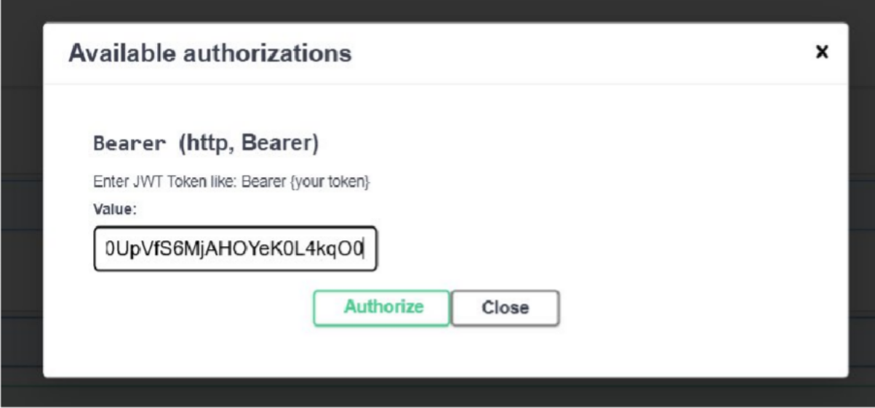

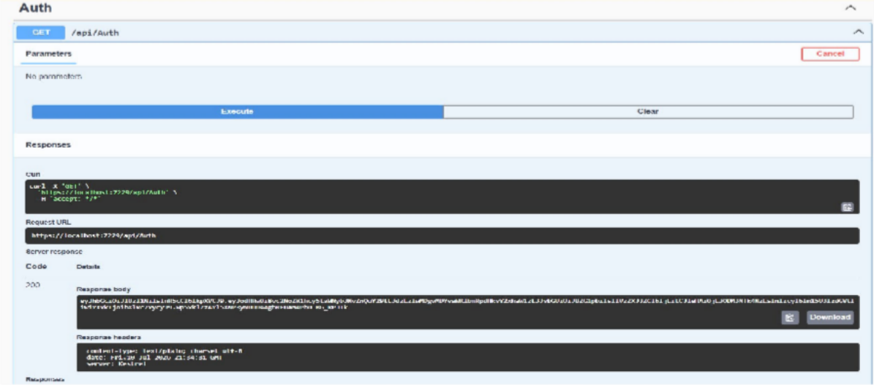

EmployeeController.cs

Remove [CustomAuthFilter]

Replace with using Microsoft.AspNetCore.Authorization;

Program.cs:

using Lab_1_WebAPI.Filters;

using Microsoft.AspNetCore.Authentication.JwtBearer; using Microsoft.IdentityModel.Tokens;
using Microsoft.OpenApi.Models; using System.Text;
var builder = WebApplication.CreateBuilder(args);

var securityKey = "mysuperdupersecretkey1234567890123456";

var symmetricSecurityKey = new SymmetricSecurityKey(Encoding.UTF8.GetBytes(securityKey));

builder.Services.AddControllers(options => { options.Filters.Add<CustomExceptionFilter>();
});

builder.Services.AddEndpointsApiExplorer(); builder.Services.AddSwaggerGen(c => {

c.SwaggerDoc("v1", new OpenApiInfo { Title = "Lab-1 WebAPI",
Version = "v1"

});

c.AddSecurityDefinition("Bearer", new OpenApiSecurityScheme { Name = "Authorization",
Type = SecuritySchemeType.Http, Scheme = "bearer",
BearerFormat = "JWT",

In = ParameterLocation.Header,

Description = "Enter JWT Token like: Bearer {your token}"

});

c.AddSecurityRequirement(new OpenApiSecurityRequirement

{

{

new OpenApiSecurityScheme

{

Reference = new OpenApiReference

{

Type = ReferenceType.SecurityScheme, Id = "Bearer"
}

},

Array.Empty<string>()

}

});

});

builder.Services.AddAuthentication(JwtBearerDefaults.AuthenticationScheme)

.AddJwtBearer(options => {

options.TokenValidationParameters = new TokenValidationParameters { ValidateIssuer = true,
ValidateAudience = true, ValidateLifetime = true, ValidateIssuerSigningKey = true, ValidIssuer = "mySystem", ValidAudience = "myUsers",
IssuerSigningKey = symmetricSecurityKey

};

});

builder.Services.AddAuthorization(); var app = builder.Build();
if (app.Environment.IsDevelopment())

{

app.UseSwagger(); app.UseSwaggerUI();
}

app.UseHttpsRedirection(); app.UseAuthentication(); app.UseAuthorization(); app.MapControllers();

app.Run();
